MPC AWS Portal check

1. Go to <https://atos-aua1.signin.aws.amazon.com/console>
2. Login with personal credentials. (DAS ID will be unique for each user)

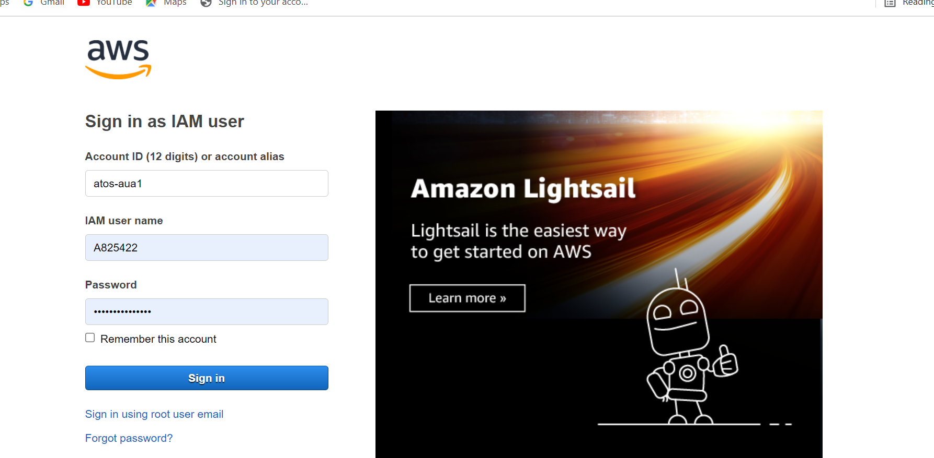

1. Click on extensions to switch in other accounts.

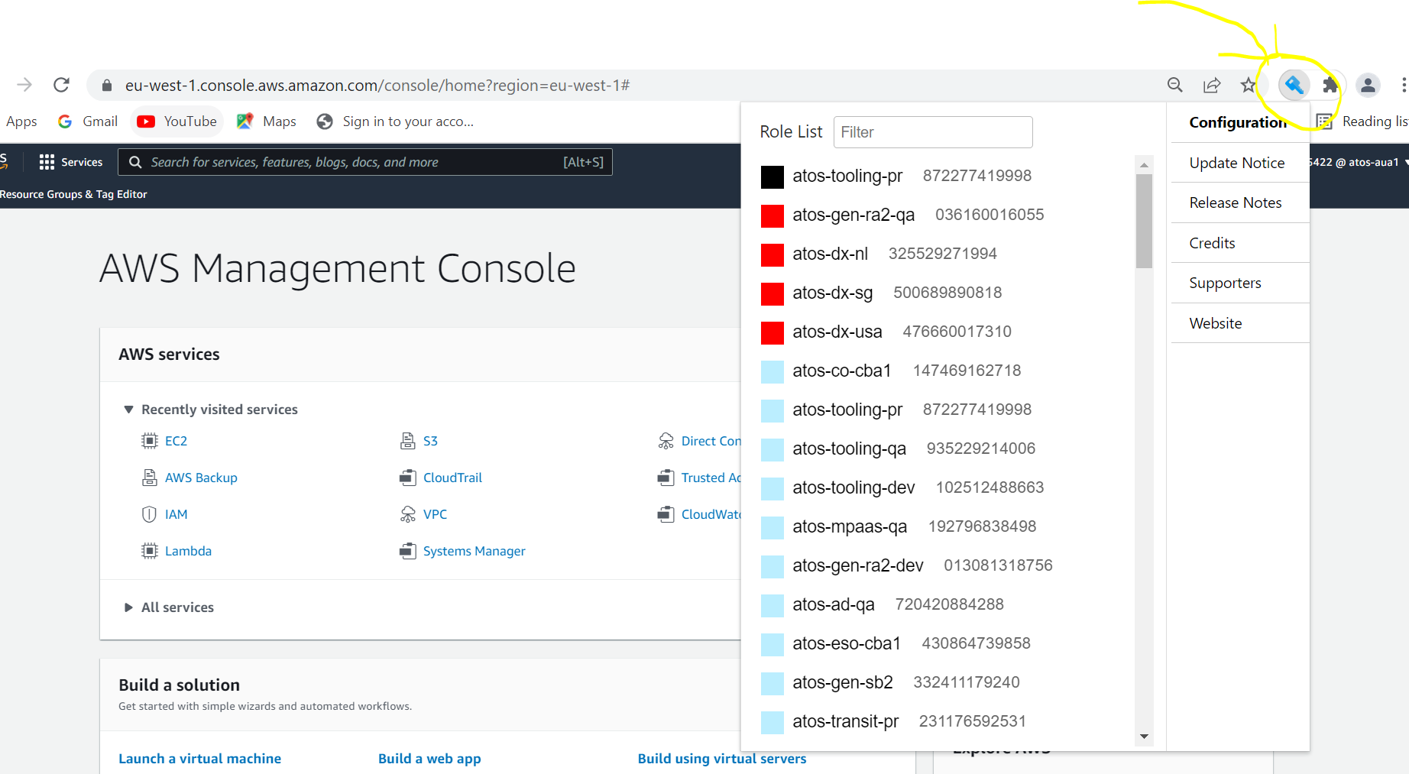

1. Check every account.

